Toy Model 5

L_Z = mbeta.*(V.*exp(-malpha.*Z));

L_V = -mbeta.*Z;

Malpha = 1

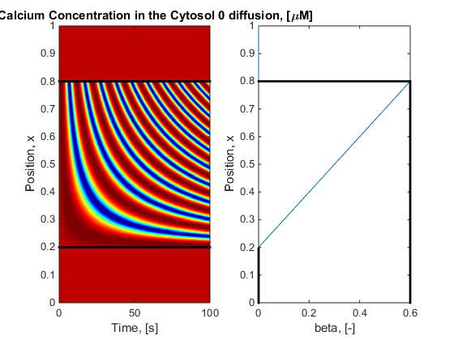

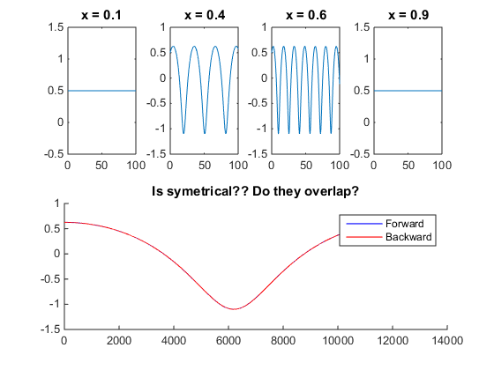

Yes they are Conidal but no they will not work as it is symmetrical front and back. Need to be Front heavy wave to protrude

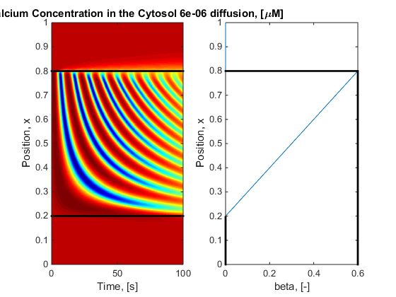

As expected